k
Object Orientend Programming
with C++
(
CSE
-2001)
PRACTICAL FILE
Name : Adhikari Viswa Teja
Reg n.o : 24MIM10138NKAR
Submitted to : Dr. Dhereesh Soni
Slot :A11+A12+A13
Introduction to
Problem Solving
(
CSE
1021)
Project Title
Library Management
System

Name : A.JEEVAN REDDY
Reg n.o : 26MIP10036
Submitted to : Dr. PRICILLA DINKAR MOYA
Slot :B11+B12+B13+C14+E11+E12

1.Introduction
The Library Management System is a Python-based application designed to handle essential library operations such as adding books, borrowing books, returning books, and searching for books. The system uses lists and dictionaries to store book data and offers a clean, menu-driven interface for easy use.
It is ideal for beginners learning Python and basic software development concepts.

2. Problem Statement
Managing books manually in a library is time-consuming and leads to errors such as misplaced records, difficulty in searching, and wrong availability status.
The goal is to build a simple digital solution to automate basic library tasks.

3. Functional Requirements
These are features the system must perform:
- Add new books with title and author.
- View all books with their current availability status.
- Borrow a book (mark as not available).
- Return a book (mark as available).
- Search books by title or author keyword.
- Exit the application safely.

4. Non-Functional Requirements
- Usability – The system should be simple and easy to use for beginners.
- Performance – The response time should be fast for all operations3. Reliability – Must correctly update the availability status of books.
- Scalability – Should allow unlimited number of books.
- Portability – Works on Windows, Mac, or Linux with Python 3.
- Maintainability – Code is modular and easy to extend.

6. System Architecture
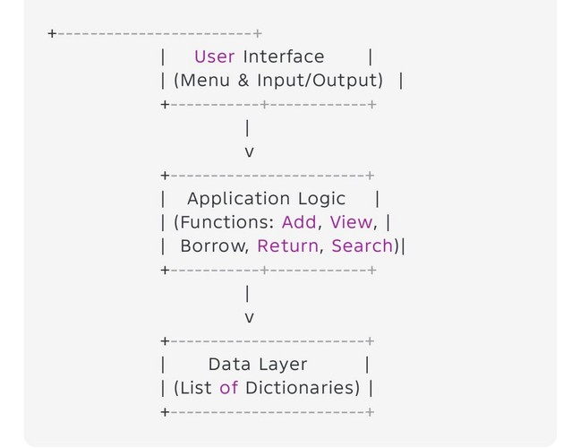

7. Design Diagrams
- Use Case Diagram
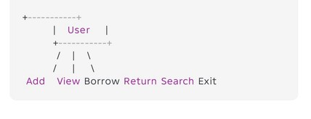
- Workflow Diagram
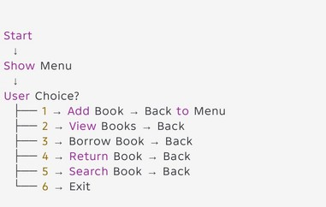

c) Sequence Diagram
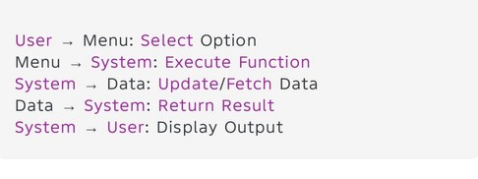
- Class/Component Diagram
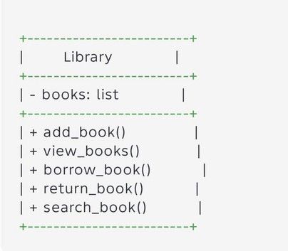
- ER Diagram (if storage used)
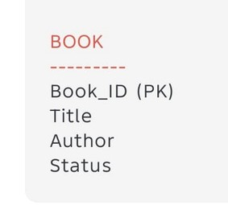

8. Design Decisions & Rationale
- List & Dictionary chosen — easiest structure for beginners.
- Menu-based interface — reduces complexity.
- No database — makes it simple and portable.
4 .separate function — improves readability and debugging.

9. Implementation Details
Programming Language: Python 3
Data Structure: List of dictionaries
Modules Used: None (only built-in features) User interacts using simple CLI prompts (input()) Each book stored as:
{"title": ..., "author": ..., "available": True}
9. Implementation Details
Programming Language: Python 3
Data Structure: List of dictionaries
Modules Used: None (only built-in features) User interacts using simple CLI prompts (input()) Each book stored as:
{"title": ..., "author": ..., "available": True}

10. Screenshots / Results
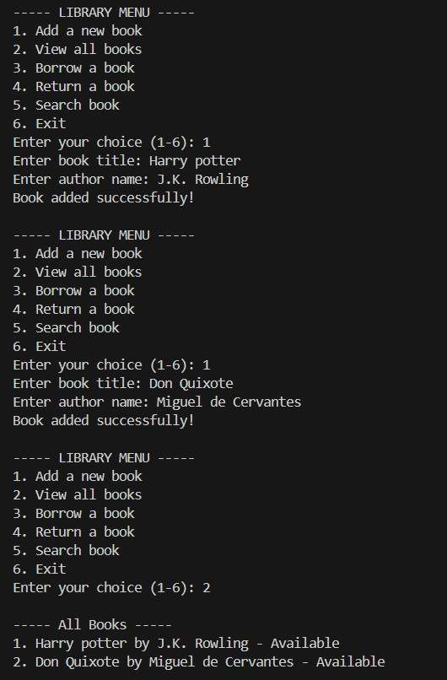

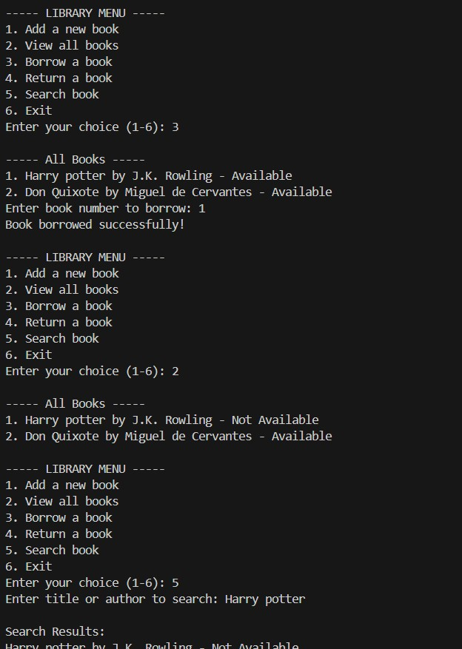

11. Testing Approach
Types of Testing Performed:
Functional Testing (each option tested)
Boundary Testing (empty list, invalid book number)
Input Validation (incorrect input)
Integration Testing (functions working together)
Test Cases:
Test Case Input Expected Output
Add book Title + Author Book added
Borrow invalid number 999 Error message
Search “Harry” Keyword Matching books

12. Challenges Faced
Handling invalid user inputs (like wrong numbers).
Maintaining book status (available/not available).
Ensuring the menu loop runs properly without crashing.

13. Learnings & Key Takeaways
Learned how to use lists and dictionaries effectively.
Gained understanding of modular programming using functions.
Understood basic software architecture and diagrams.
Learned how console-based applications work.

14. Future Enhancements
Add permanent file storage (CSV/JSON).
Add book IDs and user ID system.
Add login system for admin & users.
Implement GUI using Tkinter.
Add due date + fine calculation.
Convert into a full web app (Flask/Django).

15. References
Python Documentation – https://docs.python.org
Online Tutorials – W3Schools, GeeksForGeeks
Class Notes & Materials

